**WIRESHARK PROGRAMS**

G P ABINAYA (192211241)

**DHCP**

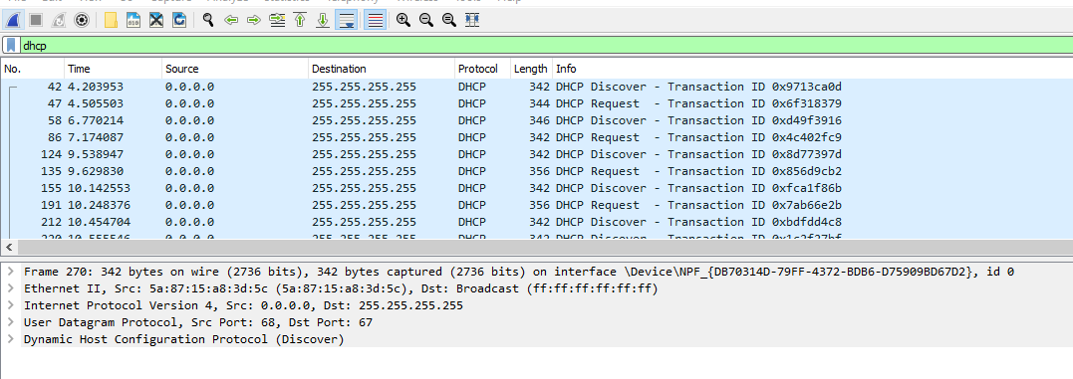

**TCP**

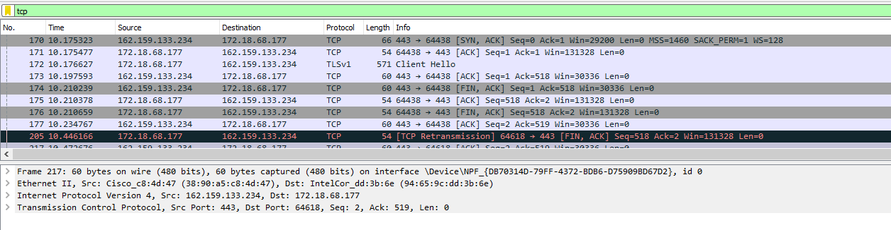

**ICMP**

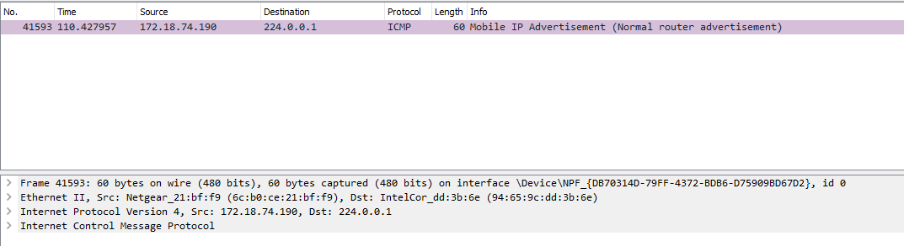

**UDP**

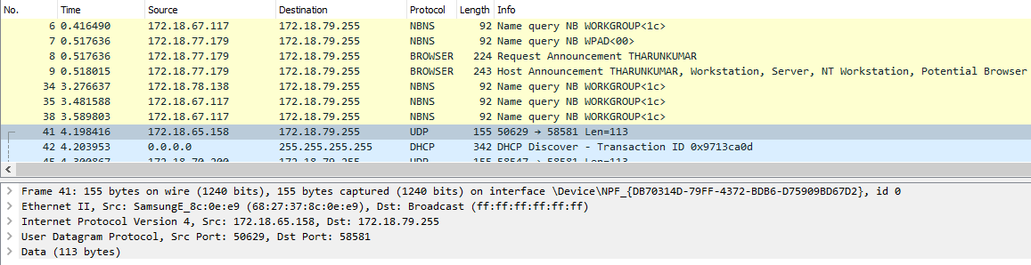

**ARP**

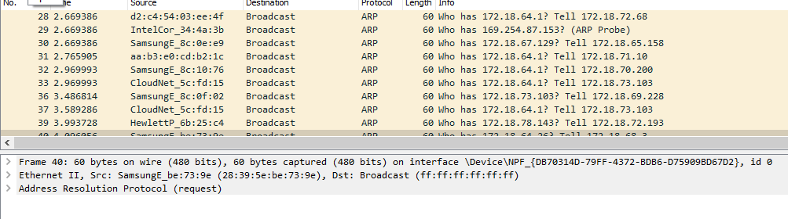

**HTTP**

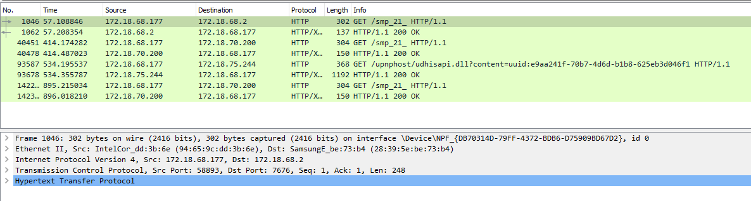

**IPv4 stat**

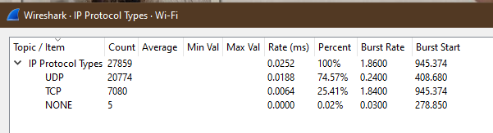

**IPv6 stat**

